

**Disclaimer: The content is curated from online/offline resources and used for educational purpose only**



**LAB MANUAL**

**Unit III – Power BI for Data Analysis**

**Unit III – Heat map dashboard using power BI**

**Objective:**

The purpose of this lab session is to teach students how to visualize monthly and yearly rainfall data using a heat map in Power BI. By the end of the session, students will learn how to import, transform, and clean data, create heat maps to identify rainfall patterns, and analyse trends across different months and years. They will also learn how to present insights effectively using dashboards.

**Prerequisites:**

* Basic knowledge of Power BI (interface and common visualizations).
* Familiarity with Excel/CSV file formats.
* Basic understanding of data analysis concepts like aggregation, grouping, and filtering.
* Basic knowledge of time-series data and its application in forecasting.

**Software Required:**

* Power BI Desktop (latest version)

**1. Prepare the Rainfall Data**

Ensure your dataset is structured properly. For example:

| **Region** | **Month** | **Rainfall (mm)** |
| --- | --- | --- |
| North | January | 120 |
| North | February | 80 |
| South | January | 100 |
| South | February | 60 |

* **Region/Location:** Represents different areas.
* **Month:** Represents the time dimension.
* **Rainfall:** Represents the measured rainfall values.

**2. Load Data into Power BI**

1. Open Power BI Desktop.
2. Import your dataset (e.g., Excel, CSV) using **Get Data**.

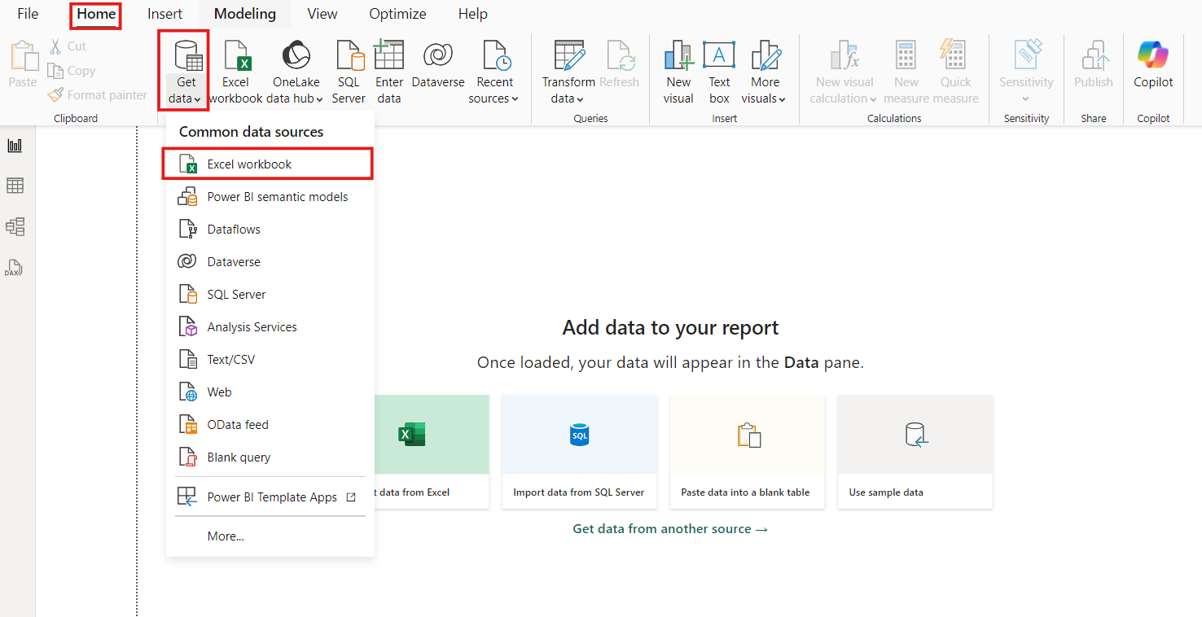

**3. Create a Matrix Visual**

1. Drag and drop the **Matrix** visual onto the report canvas.
2. Populate the Matrix:
   * **Rows:** Add Region (or location).
   * **Columns:** Add Month.
   * **Values:** Add Rainfall.

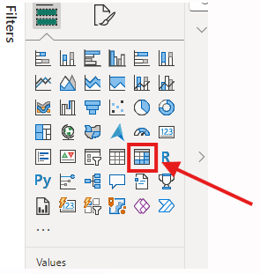

**4. Format the Matrix as a Heatmap**

1. Go to the **Pane and select the roes, columns and values**

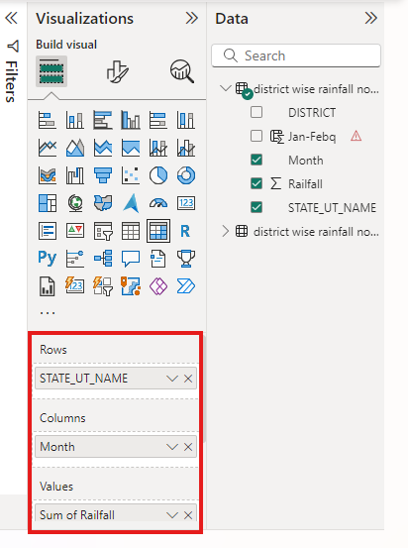

1. In the **Conditional Formatting** section:
   * Click on the dropdown beside the **Rainfall** field in the Values section.
   * Choose **Conditional Formatting > Background Color**.

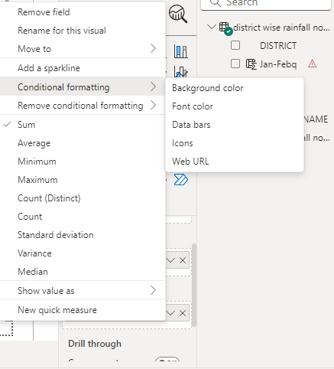

1. Set up the background color rules:
   * Use a gradient color scale (e.g., blue for low rainfall to red for high rainfall).
   * Adjust the minimum and maximum values based on your dataset to enhance visibility.

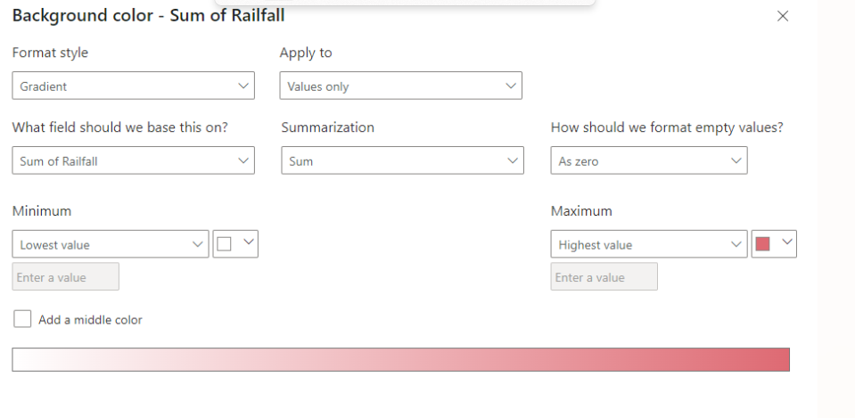

**5. Customization**

* Customize fonts, borders, and gridlines to make the heatmap more visually appealing.

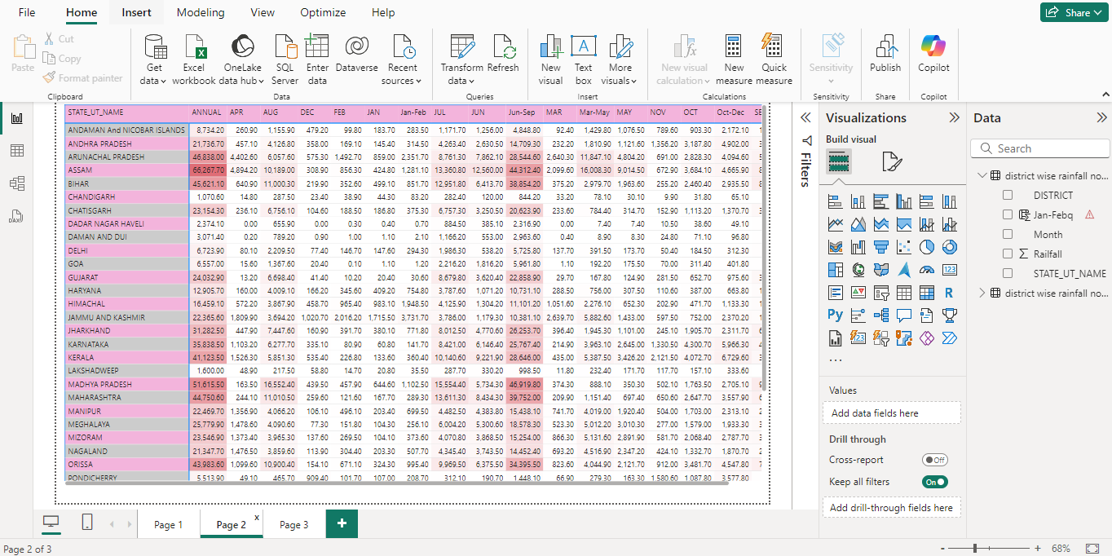

**Conclusion**

The seasonal trend in rainfall is revealed through the heat map. Certain months consistently receive higher rainfall, such as during monsoon. Year-wise variation indicates fluxes in total rainfall from year to year, which may reflect changes in long-term patterns of climate. Significant variations may exist in certain years, showing higher or lower rainfall, and indicating anomalies or extreme weather events. The map also indicates consistent regional differences, which, in some months or years, depict much more focused rainfall in certain areas. Taken together, the analysis highlights potentially useful insights about the seasonal and yearly trends of rainfall, helping to predict these patterns and manage resources accordingly.